1. **Scale ED Mapping Upgrade v1.3**

**20584:** Shrunk Subsurface Structures’ Duct Junction subtype (“Enlosures” layer) from size 10 to size 5 (Repeat for proposed)

Before: After:

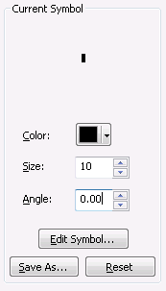 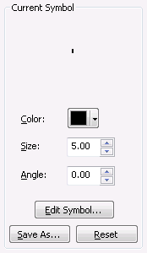

**20661:** 1) Modified Duct Bank symbology to include a black outline with white fill

Before: After:

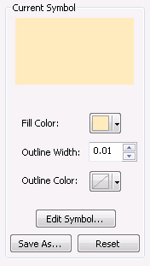 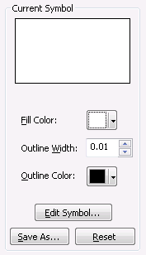

1. Modified Duct symbology to use a solid black outline with a grey fill (20%) for occuplied and a solid white fill for unoccupied

Before:

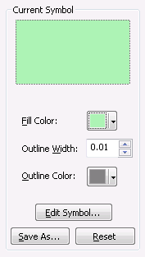 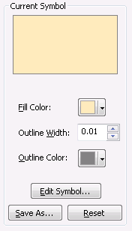

After:

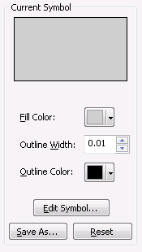 

Upon completion:

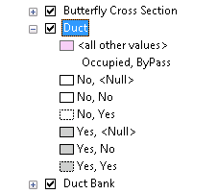

**20585: Add Network Protector Annotation**

